Lab2 Data Science
111501030
vishal kumar chaudhary

DataSet used is Facebook Comment Volume Dataset Data Set part ->Features_Variant_5.csv
Observation :
1) with increase in lamda ,error decreases ,but overfitting in the last happens
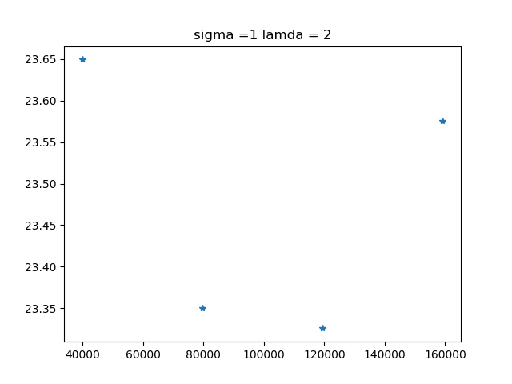
2) when we increase the training set the rms error decrease but with high increase in training data it overfits the data and hence error on test data increase .
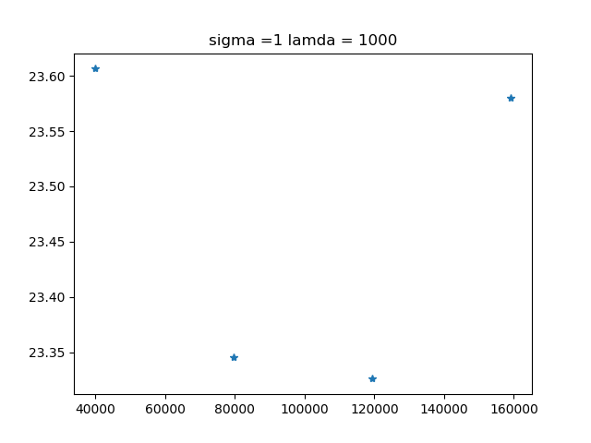

3) the learning pattern remains same but for this combination of lamda and sigma initial error increases ,but overfitting decreases.
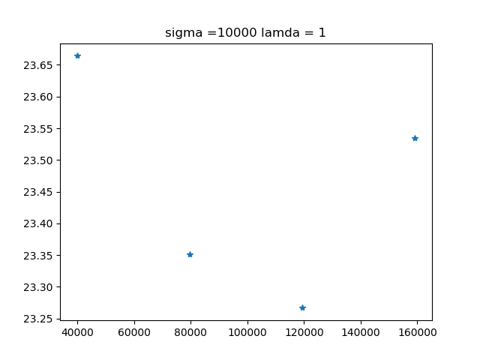
4)With same lamda and sigma but higher value , initial error is increase but follows the overfitting pattern.
